ENGR 3321 - Lab 4: Wireshark UDP

14 October 2022

Nathan Cauwet

873271826

1. *Select one UDP packet from your trace. From this packet, determine how many*

*fields there are in the UDP header. (You shouldn’t look in the textbook! Answer*

*these questions directly from what you observe in the packet trace.) Name these*

*fields.*

There are 4 fields: source, destination, length, and checksum

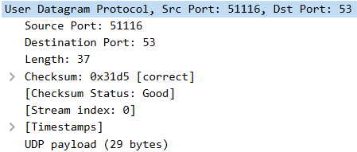

2. *By consulting the displayed information in Wireshark’s packet content field for*

*this packet, determine the length (in bytes) of each of the UDP header fields.*

payload = 29 bytes, Length = 37, total length of IPv4 = 57, IPv4 header = 20

ipv4 length – ipv4 header length = 57-20 = 37 = Length

Length - payload = 8 bytes = UDP header size

If you click on User Datagram Protocol, it says the header is 8 bytes (verifying total UDP header size that I calculated above).

Since there are 4 header fields and the total header size is 8 bytes, **each header is 2 bytes**.

3. *The value in the Length field is the length of what? (You can consult the text for*

*this answer). Verify your claim with your captured UDP packet.*

Value in length field = 37 = the IPv4 packet (total size minus the header)

ipv4 packet = ipv4 length – ipv4 header length = 57-20 = 37 = Length

**It is the length of the IPv4 packet**

**UDP payload + UDP header = 29 + 8 = 37 bytes = UDP packet length**

4. *What is the maximum number of bytes that can be included in a UDP payload?*

*(Hint: the answer to this question can be determined by your answer to 2. above)*

The maximum length of a UDP packet is (216 - 1) bytes (including the 8 header bytes), therefore maximum number of bytes allowed in a UDP payload is (216 - 1)bytes – 8bytes = **65527 bytes**



5. *What is the largest possible source port number? (Hint: see the hint in 4.)*

The largest possible source port number is = (216 - 1) = 65535

6. *What is the protocol number for UDP? Give your answer in both hexadecimal and*

*decimal notation. To answer this question, you’ll need to look into the Protocol*

*field of the IP datagram containing this UDP segment (see Figure 4.13 in the text,*

*and the discussion of IP header fields).*

UDP protocol number is 17 in decimal and 0x11 in hexadecimal

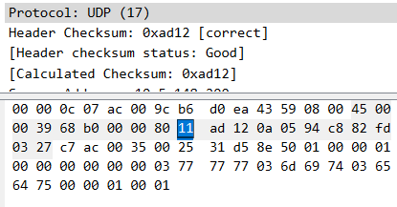

7. *Examine a pair of UDP packets in which your host sends the first UDP packet and*

*the second UDP packet is a reply to this first UDP packet. (Hint: for a second*

*packet to be sent in response to a first packet, the sender of the first packet should*

*be the destination of the second packet). Describe the relationship between the*

*port numbers in the two packets.*

The port numbers in the two packets are the same with the source and destination switched (src1 = dest2 and src2 = dest1).

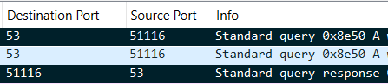

The expanded details from the selected packet are included below: